1) a) Is the number of petitions with Data Engineer job title increasing over time?
b) Find top 5 job titles who are having highest avg growth in applications.[ALL]
[no sub menu is required]

output a:

select job_title,count(*),year from h1b_final where job_title='DATA ENGINEER' group by job_title,year order by year;

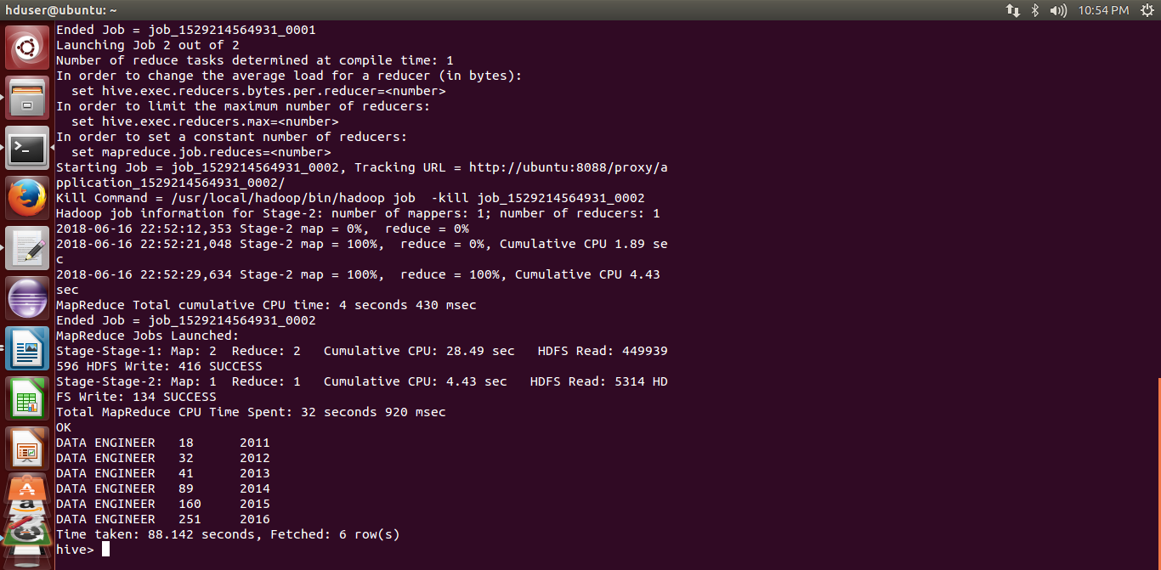

2) a) Which part of the US has the most Data Engineer jobs for each year?
b) find top 5 locations in the US who have got certified visa for each year.[certified]
[sub menu - year option is required]

output a:

create table site as select COUNT(job_title) as most,job_title,worksite,year from h1b_final where job_title='DATA ENGINEER' group by job_title,worksite,year;

select * from site a where most in (select max(most) from site b where b.year=a.year) order by a.year;

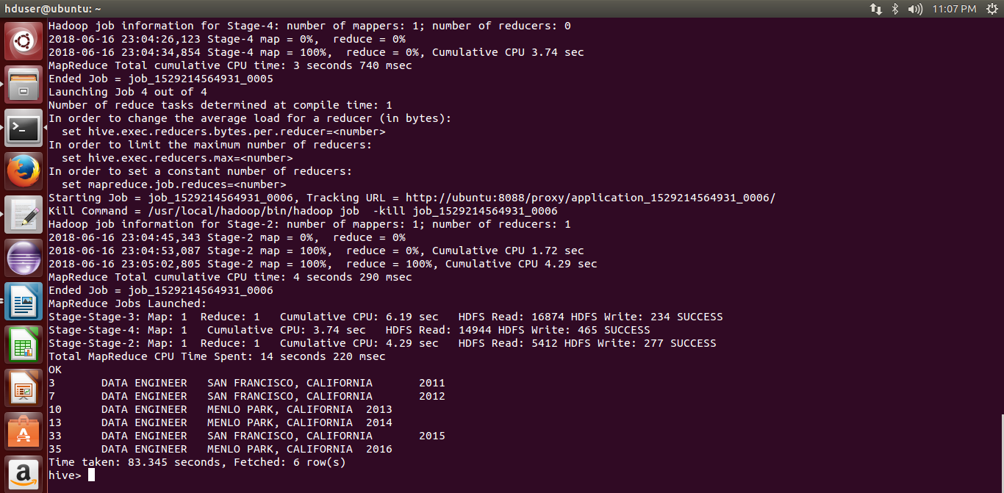
3) Which industry(SOC_NAME) has the most number of Data Scientist positions?
[certified]
[no sub menu is required]

output:

create table soc as select count(job_title) as most,soc_name,case_status,job_title from h1b_final where job_title='DATA SCIENTIST' and case_status='CERTIFIED' group by soc_name,case_status,job_title;

select * from soc where most in (select max(most) from soc);

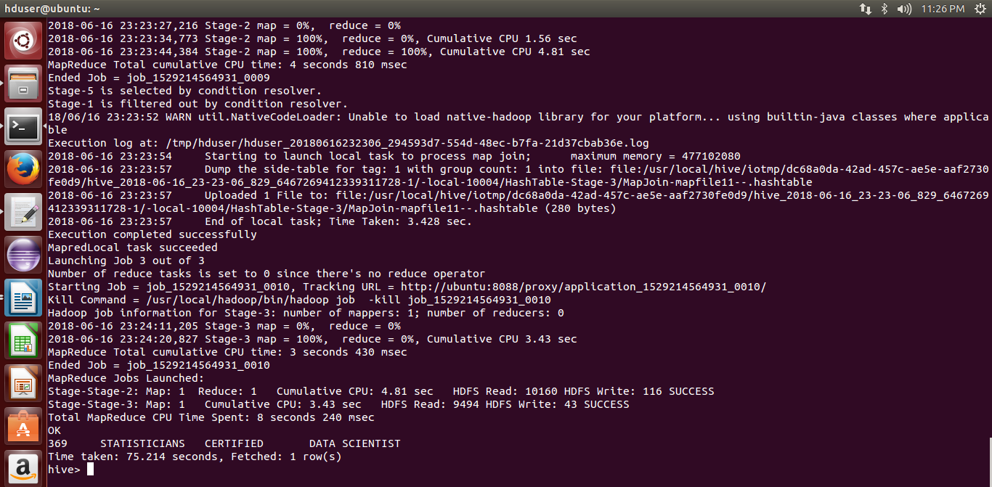

4) Which top 5 employers file the most petitions each year? - Case Status - ALL
[sub menu - year option is required]

output:

select count(*) as total,employer_name,year from h1b_final where year='2011' group by employer_name,year order by total desc limit 5;

same for all years from 2011 - 2016



5) Find the most popular top 10 job positions for H1B visa applications for each year?
a) for all the applications
b) for only certified applications.
[second sub menu - year option is required]

output a:

select count(job_title) as total,job_title,year from h1b_final where year = '2016' group by job_title,year order by total desc limit 10;

same for all other years 2011,2012,2013,2014,2015,2016

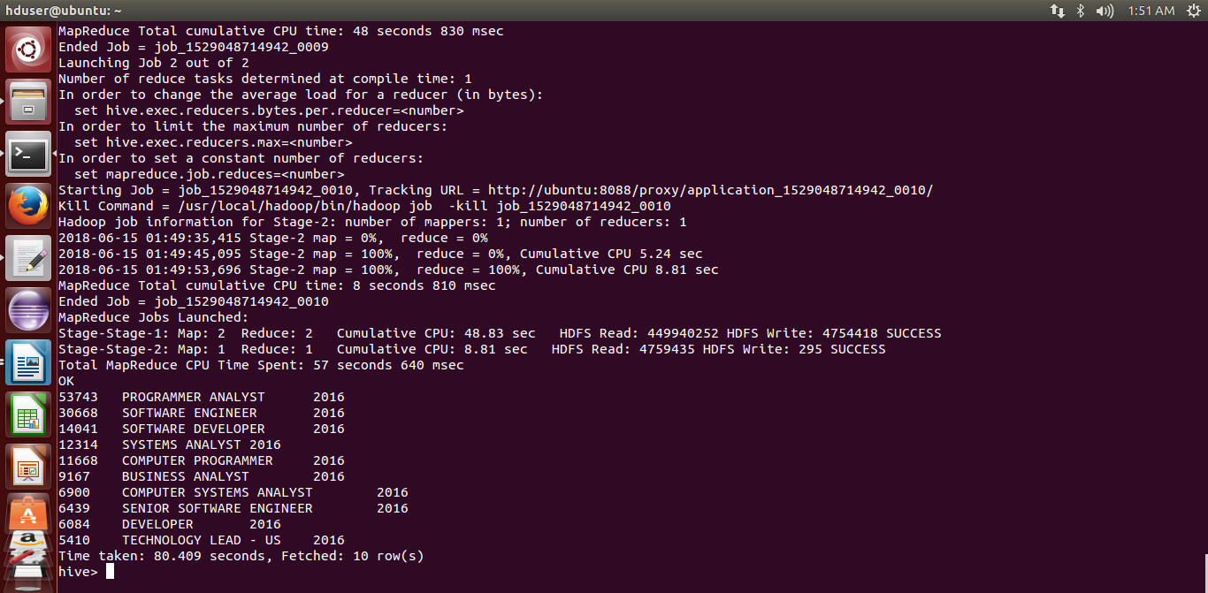
output b:

select count(job_title) as total,job_title,case_status,year from h1b_final where year = '2016' and lower(case_status)='certified' group by job_title,case_status,year order by total desc limit 10;

same for all years

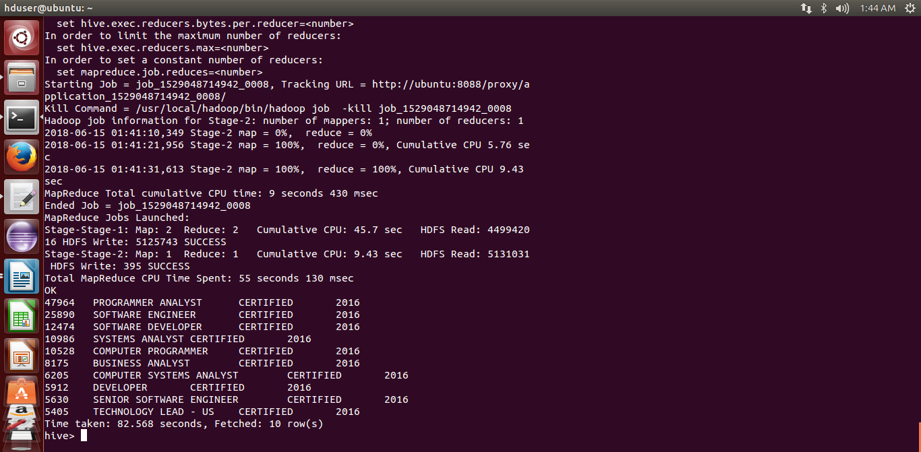

6) Find the percentage and the count of each case status on total applications for each year.

Create a line graph depicting the pattern of All the cases over the period of time.
[no sub menu is required]

/home/hduser/pig programs/Project /h1b6/Link to h1b6.pig#h1b6

output:



7) Create a bar graph to depict the number of applications for each year [All]
[no sub menu is required]

yet to be done

8) Find the average Prevailing Wage for each Job for each Year (take part time
and full time separate). Arrange the output in descending order - [Certified and
Certified Withdrawn.] [Top 20 only required]
[first sub menu - full time OR part time]
[second sub menu - year option is required]

Full Time Position:

/home/hduser/pig programs/Project /h1b8/Link to h1b8full.pig#h1b8fulltime

output for full time position :


Hive Query :

select year,job_title,full_time_position,case_status,avg(prevailing_wage) as average from h1b_final where full_time_position = 'Y' and year = '2011' group by year,job_title,full_time_position,case_status,prevailing_wage having case_status = 'CERTIFIED' or case_status = 'CERTIFIED-WITHDRAWN' order by average desc limit 20;

For full time= Y, write query for year 2011-2016
For full time= N, write query for year 2011-2016

Part Time Position:

/home/hduser/pig programs/Project /h1b8/Link to h1b8part.pig#h1b8parttime

output for part time position :



9, 10 same programs....yet to be done

